The Cultural Alliance of York County and the County of York are offering York County students in grades K-12 the opportunity to design our next "I Voted!" sticker.

Entries will be accepted from 12:00 pm on Monday March 17, through 12:00 pm Friday May 30, 2025. A committee of local educators and artists will choose one winning design from each age group. The winners will be announced at the York Revolution home game on July 29th, with free game tickets for each winner and their family. The winning designs will be produced and available at voting locations across York County during the general election in 2025 and the primary election in 2026.

To enter, please fill out the submission form on the back, design your sticker, and submit it to us via mail, email to kelley@culturalyork.org, or drop off in person.

Tips

2" x 2"

 Your design will be on a sticker 2" in diameter so make sure words or images are large enough to see from a distance.

 Take inspiration from the picturesque landscapes and iconic landmarks of York County.

 Don't limit yourself—feel free to use your imagination and create something unique!

For full contest rules, visit us at [www.culturalyork.org](http://www.culturalyork.org/). Email scanned design forms to [kelley@culturalyork.org](mailto:kelley@culturalyork.org)

Mail by May 30th to: Cultural Alliance of York County 2536 Eastern Blvd PMB 402

York, PA 17402

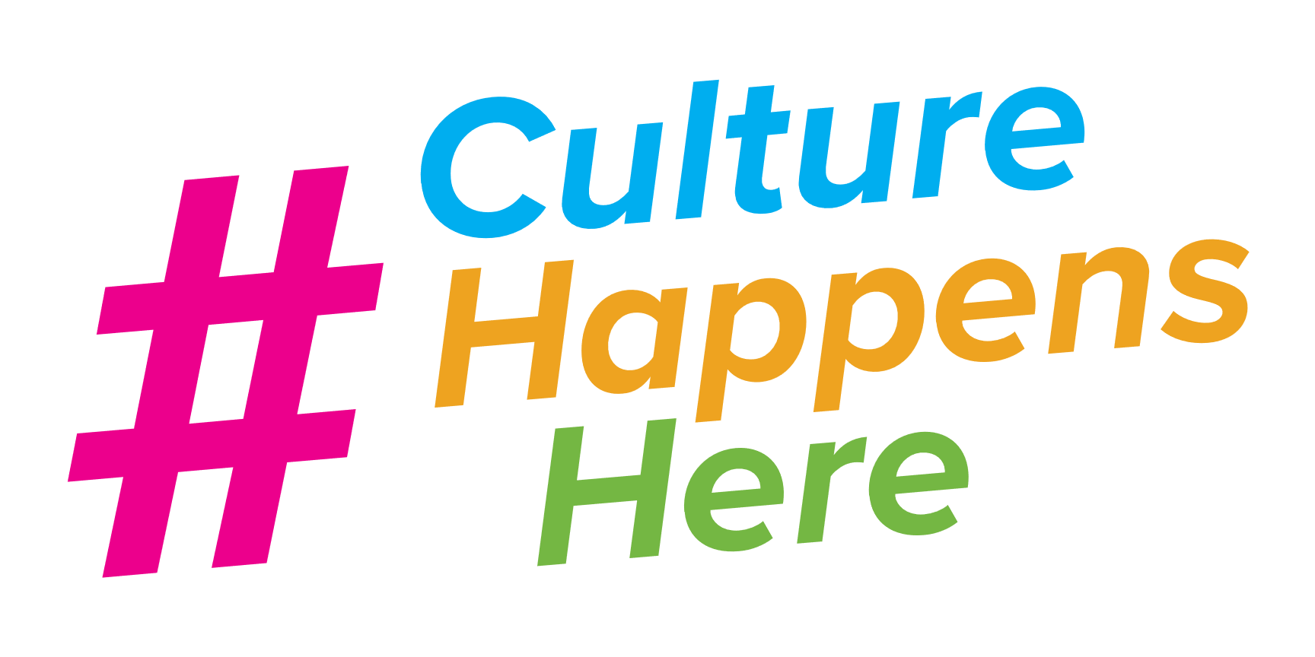717-812-9255

Name

Street Address City State Zip Code

School

Grade Level K-5 6-8 9-12

Phone Email

Mail to: Cultural Alliance

2536 Eastern Blvd, PMB 402 York, PA 17402

Email to [kelley@culturalyork.org](mailto:kelley@culturalyork.org)